Exploratory Data Analysis

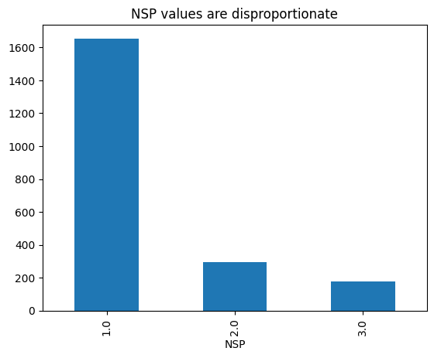

1.NSP (Y variable) is imbalanced so need to apply smote (Synthetic Minority Over-sampling) during data preprocessing. Smote is a machine learning method used to address imbalanced datasets.

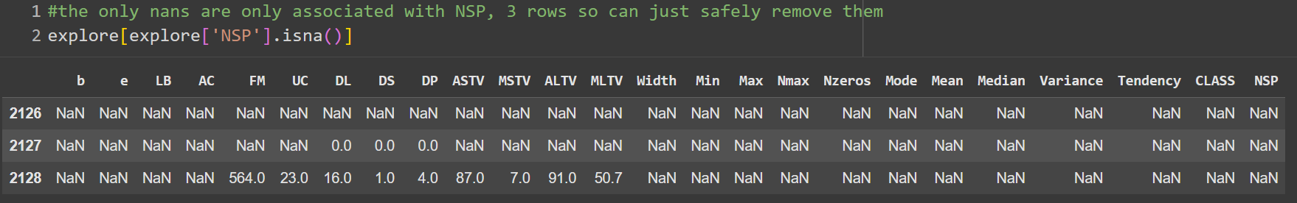

2. There were only 3 rows containing missing values, accounting for just 0.14% of the entire dataset. Given this negligible proportion, these rows were removed prior to analysis to maintain data clarity without impacting overall results. In addition, further augmentation of the dataset will be performed through the application of SMOTE, ensuring a sufficiently large and balanced sample for modeling. This combined approach guarantees both data integrity and effective handling of class imbalance.
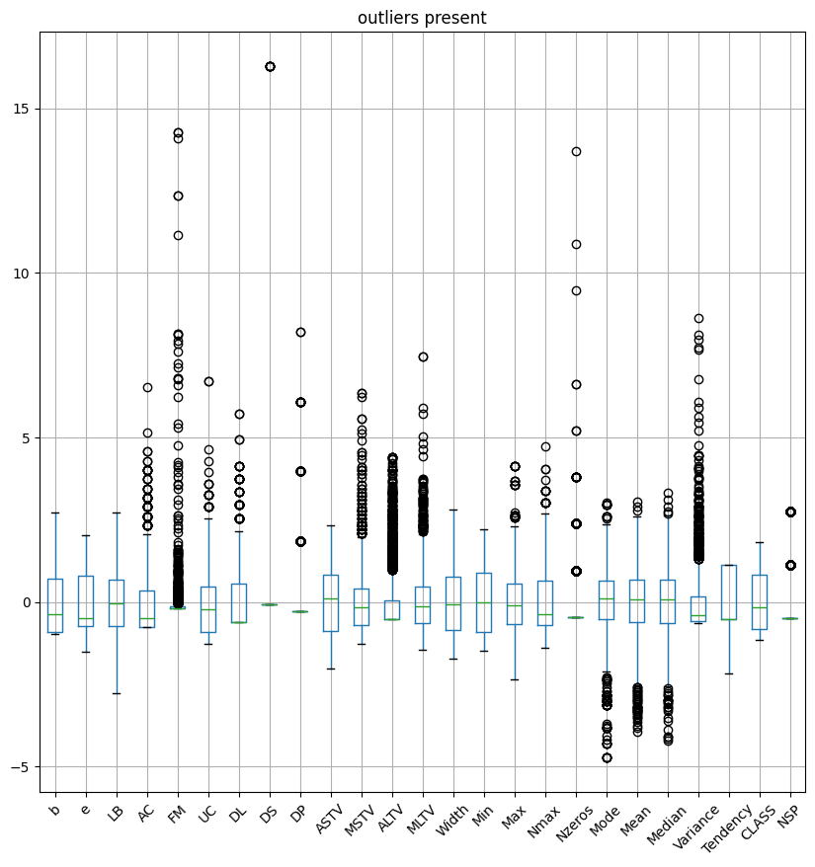
3. The dataset contains many outliers, visible as circles in the plot above. In the data preprocessing stage, it is crucial to handle these outliers appropriately to avoid their adverse effects on model performance. The chosen method for outlier detection is the Z-score technique, which measures how many standard deviations a data point deviates from the mean.

Once identified, these outlier values are replaced with NaNs (null values) to mark their removal. To preserve the integrity of the dataset and avoid loss of information, these missing values are then imputed using the K-Nearest Neighbors (KNN) algorithm. KNN imputation estimates missing values by averaging the closest neighboring samples in the feature space, providing a more contextually relevant replacement than simple mean or median imputation.

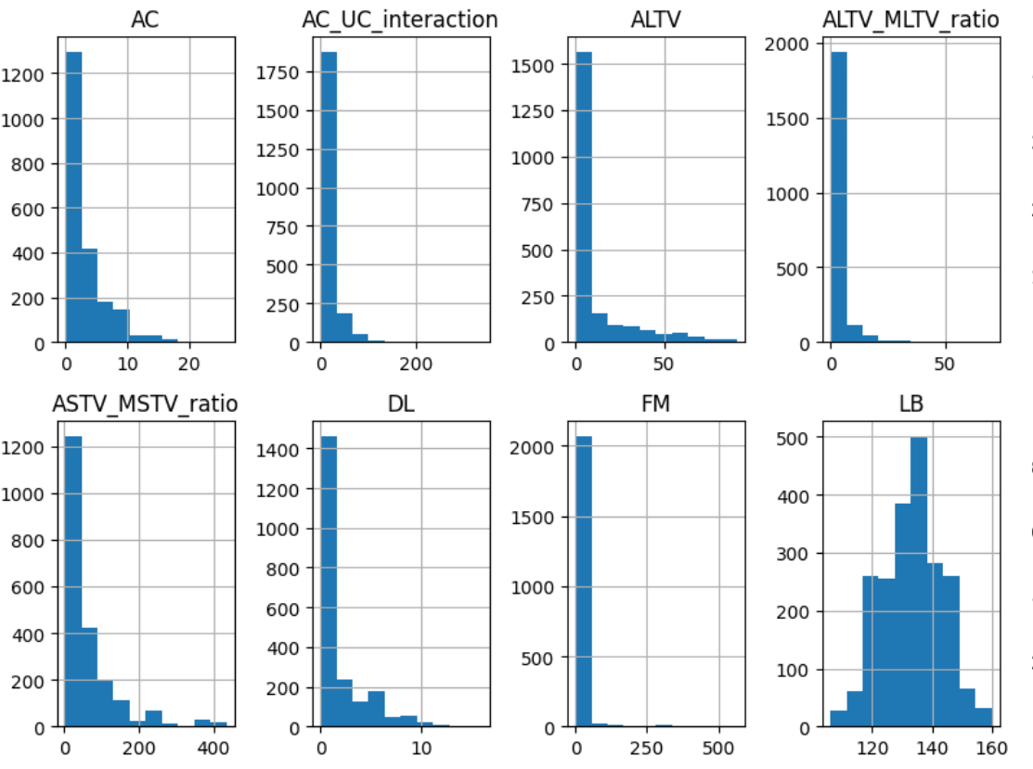

4. Several features in the dataset, such as AC and ALTV, exhibit right-skewed distributions. To address this skewness and improve model performance, a log transformation is applied to these features. The log transformation compresses the range of large values and spreads out smaller values, resulting in distributions that are closer to normal (bell-shaped). Transforming skewed features to approximate normality reduces the influence of extreme values, stabilizes variance, and helps models that assume or perform better with normally distributed inputs to learn more effectively.

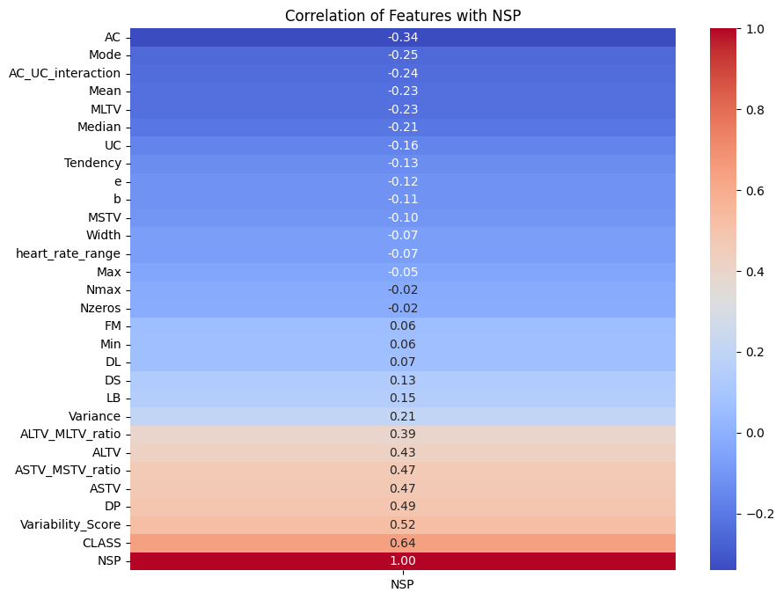
5. I realised that the ASTV/MSTV ratio offers a quantitative assessment of the balance between rapid and intermediate heart rate fluctuations. This feature is particularly informative for discerning fetal wellbeing and distress, given its strong correlation with the NSP outcome variable (correlation coefficient: 0.47).

6. Same goes with the ratio of ALTV and MLTV, the ALTV/MLTV ratio provides valuable insight into the interaction between long-term and medium-term heart rate variability. This feature demonstrates a notable correlation with NSP (correlation coefficient: 0.39), highlighting its potential for predictive modeling.

7. Analyzing the interaction between AC (Accelerations Count) and UC (Uterine Contractions) as a product, the AC_UC_interaction variable captures the physiological association between fetal heart rate accelerations and uterine contractions during labor. This feature is clinically meaningful and shows a decent correlation with NSP (correlation coefficient: -0.24)

8. By averaging ASTV and ALTV into a Variability Score, a consolidated indicator of heart rate variability is obtained. Notably, a higher Variability Score is associated with better fetal outcomes, reflected in its strong positive correlation with NSP (correlation coefficient: 0.52)

DATA PREPROCESSING

Feature Engineering
In the initial stage of the modeling pipeline, several additional features were engineered to enhance the capacity of the dataset to capture important patterns for prediction. The goal was to create derived variables that provide more meaningful representations of the underlying physiological measurements.
- ASTV_MSTV_ratio: This is the ratio of ASTV (Accelerations per second) to MSTV (Mean Short-term Variability), with a small constant added to the denominator for numerical stability. This metric can reflect the relative contribution of short-term accelerations to short-term variability, potentially illuminating abnormal physiological behavior.
- ALTV_MLTV_ratio: Similarly, this ratio of ALTV (Average Long-term Variability) to MLTV (Mean Long-term Variability) captures proportional changes in long-term variability, which may be useful for discrimination between states or classes.
- Variability_Score: Defined as the average of ASTV and ALTV, this feature provides a synthesized measure of variability that combines short- and long-term perspectives, enabling the model to access a more holistic variability index.
- AC_UC_interaction: By multiplying AC (Accelerations Count) and UC (Uterine Contractions), this interaction term models the possibility that the effect of one parameter could change depending on the value of the other, introducing nonlinearity and capturing synergistic effects.
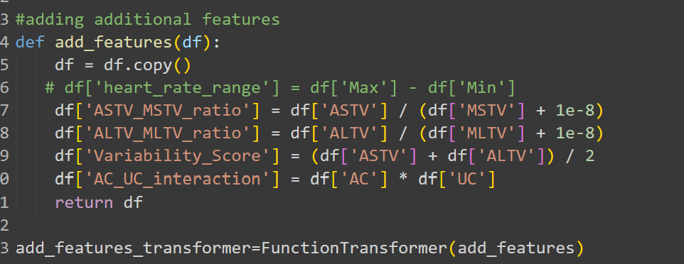
This transformation was encapsulated into a FunctionTransformer, enabling seamless integration within the data preprocessing pipeline and ensuring that feature addition is reproducible and consistent.

Log Transformation of Skewed Features
To address the challenge posed by skewed distributions in several input variables, a log transformation was applied.
This transformation was encapsulated into a FunctionTransformer for compatibility with pipelines

Outlier Detection/Removal and Imputing Removed Outliers
To improve data quality and minimize distortion from extreme observations, a Z-score based outlier removal strategy was implemented. The Z-score measures how many standard deviations a data point is from the mean

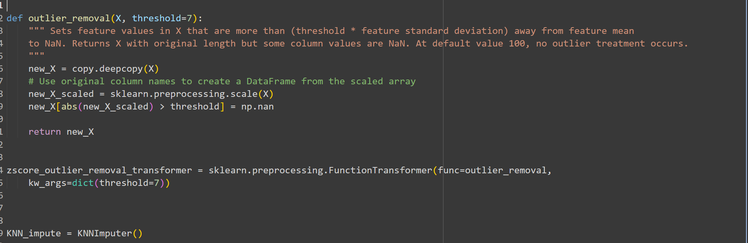
In this pipeline, any feature value in data exceeding a threshold of 77 standard deviations from the mean is set to NAN. This preserves the original shape of the data but marks extreme values for later treatment. The default threshold is intentionally high (100), so no modification occurs unless a lower value is set. This process is wrapped in a FunctionTransformer (zscore_outlier_removal_transformer) for pipeline compatibility.

After removing outlier values (setting them as NAN), missing entries are imputed using K-Nearest Neighbors Imputation (KNNImputer). This technique estimates missing values by averaging the values of the nearest (most similar) observations in the dataset. KNN imputation helps restore data completeness and prevents loss of data points, so the model can learn effectively despite outlier removal

SMOTE
To be used to handle imbalance data. Will only be applied to the training set.

Pipeline development

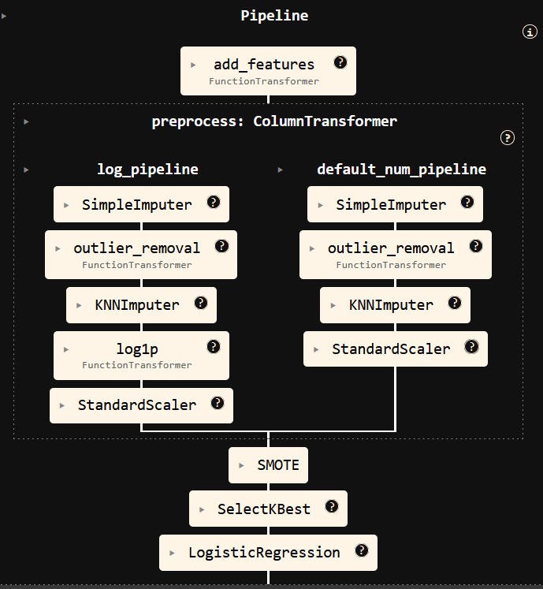
The initial step adds the engineered features using the add_features_transformer. (data has been split into train test split prior)
The pipeline branches into two paths—log_pipeline and default_num_pipeline.
log_pipeline:
This branch processes skewed features that require log transformation
- SimpleImputer:
Fills missing values with a simple strategy (e.g., mean or median).
- outlier_removal (FunctionTransformer):
Detects and marks outlier values as NaN based on a Z-score threshold.
- KNNImputer:
Imputes values set to NaN (from outlier removal or missing data) by averaging neighboring samples deemed similar.
- log1p (FunctionTransformer):
Applies the log transformation log⁡(1+x)log(1+x) to reduce skewness and stabilize variance.
- StandardScaler:
Standardizes features to zero mean and unit variance, which is necessary for many machine learning models.
Default_num_pipeline:
This branch processes "regular" numerical features that do not require log transformation:
- SimpleImputer:
Handles initial missing values.
- outlier_removal (FunctionTransformer):
Flags outliers and converts them to NaN.
- KNNImputer:
Replaces NaNs with estimated values.
- StandardScaler:
Standardizes these imputed values.
After both branches, processed columns are reassembled into a single dataset.

SMOTE layer
Synthetic Minority Over-sampling Technique is applied to balance class distributions, preventing the model from being biased toward the majority class.
SelectKbest
Selects the top k features based on a statistical score, reducing the model’s dimensionality and improving interpretability. However this layer is excluded for my tree ensemble models as I vary the max number of features during my hyperparameter tuning, making SelectKbest redundant.
Model(last layer)
Any classifier model

MODELLING RESULTS
For the models included in this experiment, I applied Random Search to tune their hyperparameters. This approach was chosen due to its efficiency and speed compared to exhaustive methods like grid search. Random Search allows the exploration of a wide range of parameter values by sampling randomly within the defined search spaces.

Metrics I used to evaluate my models are F1 macro and balance accuracy.

Choice of Metrics

F1 Macro
The F1 Macro score is a classification metric used to evaluate a model’s performance across multiple classes by computing the F1 score independently for each class and then taking the unweighted average of these scores. This approach treats all classes equally, regardless of their frequency, making it useful for imbalanced datasets where minority class performance is important.

F1 score for each class is the harmonic mean of precision and recall. F1 score is perfect as it does take into account the false negative rate indirectly because it incorporates recall, which is directly related to false negatives. In this context, minimizing false negatives is critical to ensure that at-risk fetuses receive appropriate care promptly.

Balance Accuracy
Balanced Accuracy averages recall scores of all classes to provide a more fair accuracy measure on imbalanced datasets. Again recall is important here as false negative rate is extremely important in this context.

Models

Random Forest classifier (with tuning)

Random Forest is a versatile and widely used ensemble machine learning algorithm suitable for both classification and regression tasks. It builds a collection ("forest") of decision trees, each trained on different random subsets of the data (using bootstrapping) and features (random feature selection). Each tree independently produces a prediction, and the algorithm aggregates these results—by majority voting for classification or averaging for regression—to make a final, more accurate and stable prediction.
Hyperparameters tuned: number of trees, maximum tree depth, and maximum number of features.

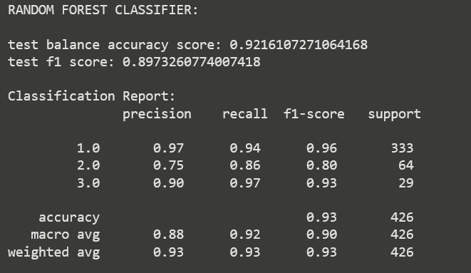

Logistic Regression (with tuning)
Logistic regression is a widely used supervised machine learning algorithm for classification tasks, particularly binary classification. It predicts the probability of an outcome belonging to a particular class based on one or more independent variables.

Hyperparameters tuned: regularization penalties,solvers values of inverse regularization strength,number of features selected (ranging from 20 to 30)

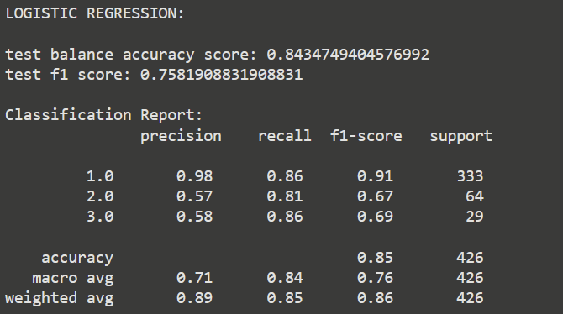

XGB Classifier (with tuning)
The XGBoost classifier (eXtreme Gradient Boosting) is a highly efficient and scalable implementation of the gradient boosting framework, specifically designed for supervised learning tasks on structured or tabular data. It operates by sequentially building an ensemble of decision trees, where each new tree is trained to correct the errors of the previous trees using gradient descent optimization.

Hyperparameters tuned: Depth range for each tree,number of boosting rounds,Fraction of samples used per tree,Fraction of features used per tree, L1 L2 regularization
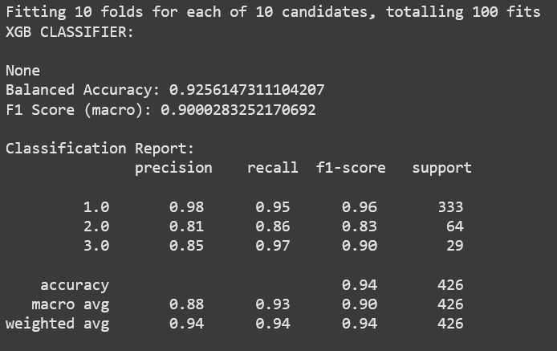

Gradient Boosting Classifier (with tuning)( BEST MODEL)

The GradientBoostingClassifier is an ensemble machine learning algorithm that builds a strong predictive model by sequentially combining multiple weak decision trees. At each stage, a new tree is trained to correct the errors (residuals) made by the prior trees, optimizing a specified loss function such as log loss for classification. This iterative process continues, with each tree's contribution scaled by a learning rate to prevent overfitting and improve generalization.

Hyperparameters tuned: number of trees, maximum tree depth, and maximum number of features.
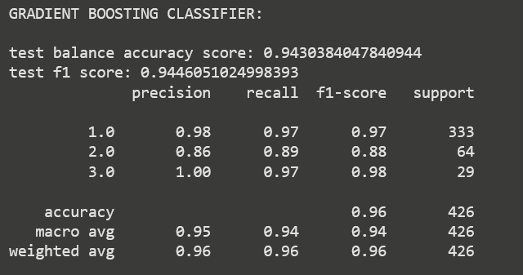

Stacked Classifier
Combined all tuned previous models into one classifier. A stacked classifier is an ensemble learning technique that combines the predictions of multiple base models to create a stronger overall model. It operates in two levels: the base models (level-0) are trained independently on the original training data, each learning different patterns or aspects of the data. Their predictions are then used as input features for a meta-model (level-1), which learns how to best combine these base model predictions to improve accuracy. It surprisingly performed slightly worse than my best model(GradientBoostingClassifier)
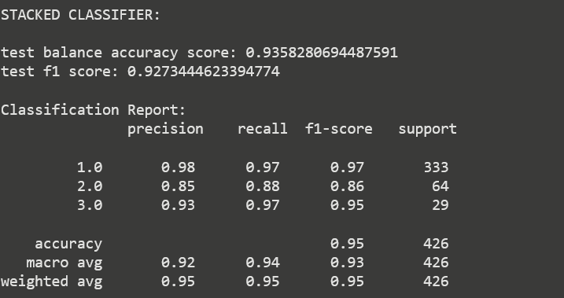

Conclusion

Gradient Boosting Classifier is the best model with 94% scores for F1 and balance accuracy score here. In addition it has the highest F1 score among all the other models. This is more important as in the medical context, false negative rates are essential (which F1 covers)

